Alat Ukur Intensi untuk keluar dari kelompok (Ind)

No | Item | 1 | 2 | 3 | 4 | 5 | 6
 |  | (Sangat Tidak Setuju) |  |  |  |  | (Sangat Setuju)
1 | Saya sering berpikir untuk meninggalkan guild saya saat ini.
2 | Saya ingin meninggalkan guild saya saat ini.
3 | Saya mulai mencari guild lain.

Michaels, C. E., & Spector, P. E. (1982). Causes of employee turnover: A test of the Mobley, Griffeth, Hand, and Meglino model. Journal of Applied Psychology, 67(1), 53-59. doi:http://dx.doi.org/10.1037/0021-9010.67.1.53

Descriptive analysis

The sample were 34 Indonesian players of Massively Multiplayer Online Role-Playing Games (MMORPGs) who were actively part of a guild at the time of the pilot study.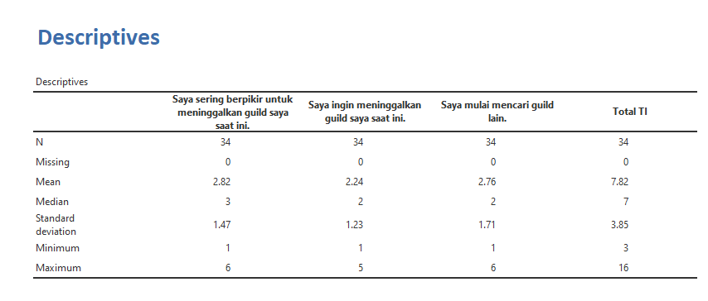

Reliability analysis
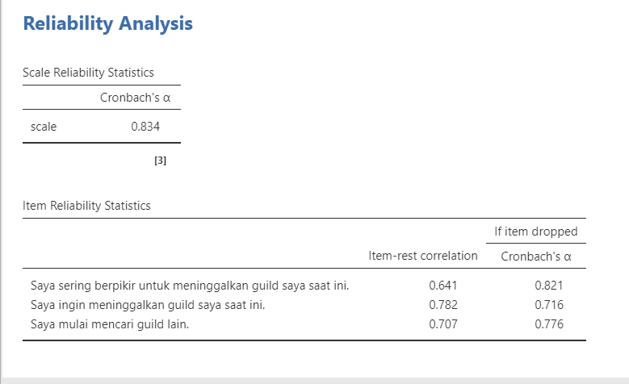

The Indonesian version was translated by Faris Ervandi Alam and Rizka Halida on 2022.

